Parts of an Expression

$5x+4$

Combining Like Terms
Use highlighters to show the like terms. Combine the terms that are alike.
Ex: $3x+5+6x+2$ Ex: $3x^{2}+5x+6x^{2}+7x+5$

Using Substitution
______________________the value and use __________________ of ____________________

Ex: $3x^{2} for x=5$ Ex: $4\left(m+3\right) for m=6$

Distributive Property
__________________ the number outside of the parentheses by both ______________ inside the parentheses.
Ex: $5(x+4)$ Ex: $7(3x-5)$

Distribute and Combine
________________ first then ____________________ like terms.

Ex: $2\left(g+4\right)+5g$ Ex: $6\left(3x+2\right)-7$

Factor
Find the __________________ _______________ ________________ of each term.
That goes on the _________________ of the parentheses. Then determine what goes on the inside.
Ex: $5x+20$ Ex: $6x+15$

Distribute to check.

Solving One Step Equations
Use Inverse Operations
Inverse operation of addition is ______________________
Inverse operation of subtraction is ______________________
Inverse operation of multiplication is ______________________
Inverse operation of division is ______________________
Ex: $x+5=12$ Ex: $m-9=12$

Ex: $7x=35$ Ex: $\frac{d}{6}=9$

Inequalities
Use a filled in circle for __________ and _________
Use an empty circle for __________ and _________
Find values that make the statement true and draw the arrow to include the true values.
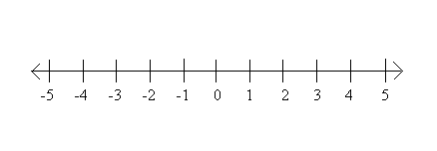
Ex: $x<3$ Ex: $x≥-2$

